SQL QUERIES

- Calculate line revenue for every order joined to customer, product and category.
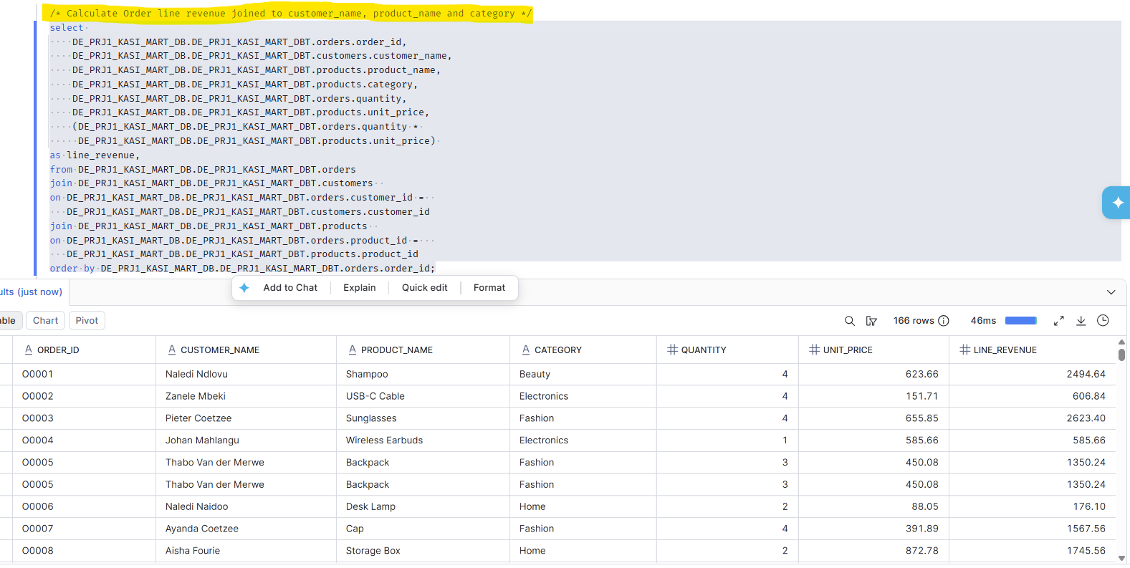

SUMMARY
This SQL query retrieves transaction data for individual customer orders by combining information from the orders, customers, and products tables within the Kasi Mart database. It extracts the order ID, customer name, product details (name and category), and order quantity, while dynamically calculating a new field called line_revenue (quantity multiplied by unit price) for each line item.

This query is crucial for business operations and analytic because by calculating exact revenue per line item and organizing it sequentially by order ID, it enables the business to track purchasing patterns, identify high-value customers, evaluate top-performing product categories, and drive data-backed financial reporting.

- Total revenue per customer query.
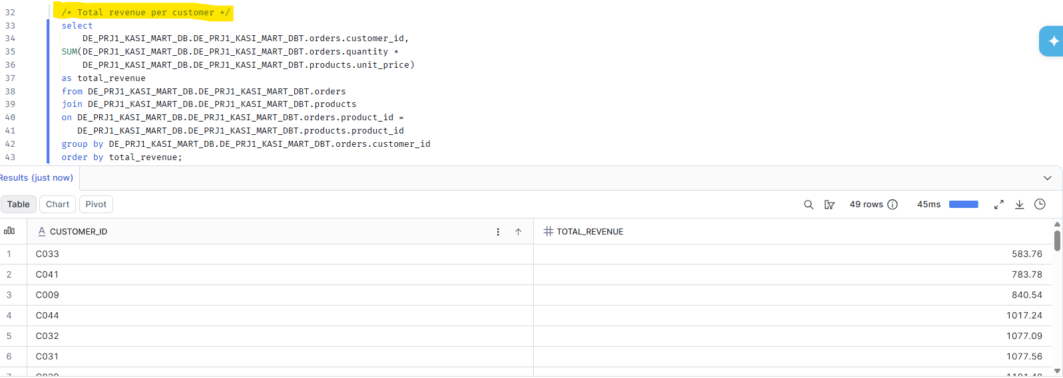

SUMMARY
This SQL query calculates the total revenue generated by each customer by multiplying the quantity of items ordered by their respective unit prices and grouping the results by customer ID. Understanding this metric is critical because it highlights the organization’s most financially valuable clients.
By sorting the data by revenue, the business can easily pinpoint its lowest and highest-spending segments, allowing marketing and sales teams to design targeted retention strategies, optimize loyalty programs, and allocate resources efficiently to maximize profitability.

- Total revenue per category.
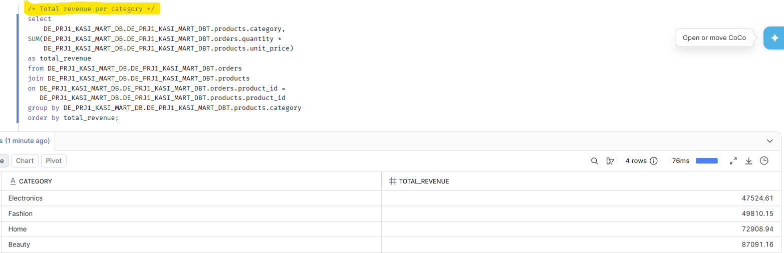

SUMMARY
This SQL query calculates and displays the total revenue generated by each product category. By joining the orders and products tables on the shared product_id, the query multiplies the quantity of items ordered by their respective unit prices, grouping the final sums by product category.
This information is critical for business intelligence and financial health assessment. It helps stakeholders identify top-performing product segments, pinpoint under-performing categories that may require strategic marketing or inventory adjustments, and make data-driven decisions regarding stock allocation and overall business growth.

- Top 5 customers by customer-spend.
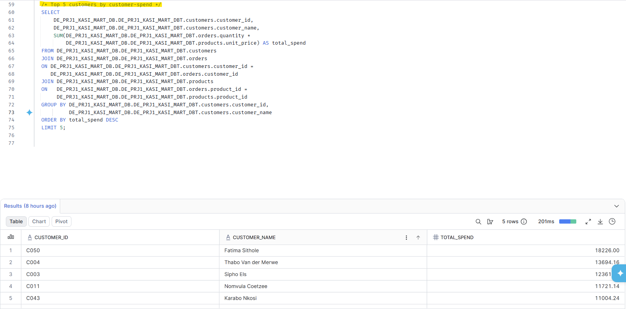

SUMMARY
This query retrieves the top 5 highest-spending customers at Kasi Mart by calculating their lifetime or total expenditure. By joining the customers, orders, and products tables, it multiplies the quantity of items ordered by their respective unit prices to find the total_spend per individual, sorted from highest to lowest. This data is critical for business intelligence because it identifies the store's most valuable customers (VIPs). Businesses use these insights to drive targeted loyalty programs, design exclusive marketing campaigns, and implement retention strategies to protect their highest revenue-generating relationships.

